Project Design Phase-II
Data Flow Diagram & User Stories

Date | 30 September 2026
Team ID | SWTID-2026-1669
Project Name | AI WEATHER WISE APL
Maximum Marks | 4 Marks

Data Flow Diagrams:
The user enters the location into AI Weather Wise, the system collects weather data from the Weather API, AI analyses the data, and the forecast, weather conditions, and alerts are displayed to the user.
Example: DFD Level 0 (Industry Standard)

Example: (Simplified)
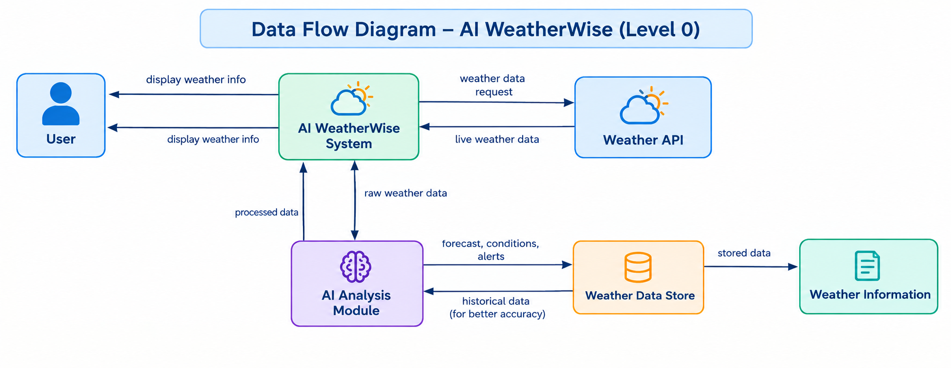
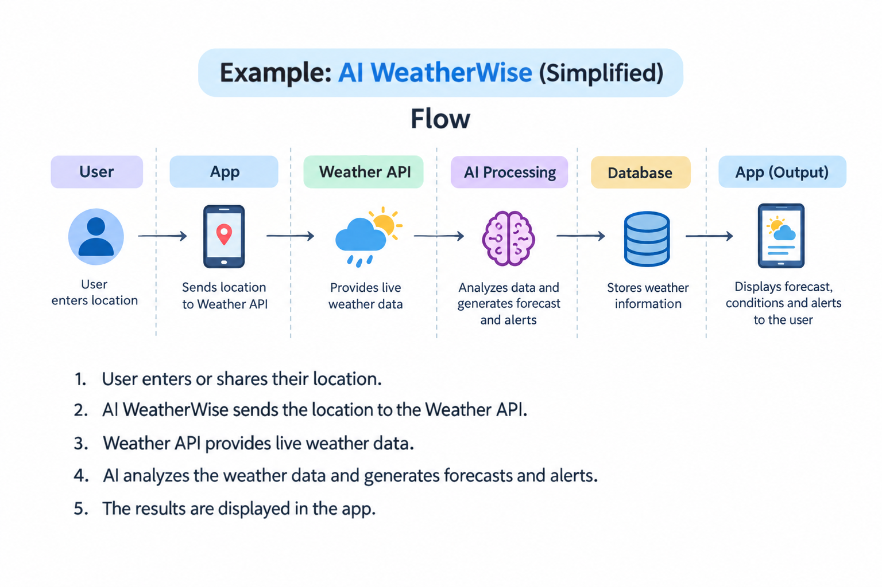

User Stories:
